Timesheets are legal documents, they are used for accounting purposes and to help MCC document our AmeriCorps grant requirements. Timesheets are required for AmeriCorps participants in order to verify the number of hours served during a term of service as well as to document for our project partners that MCC individuals and crews are meeting partner expectations. Timesheets must be completed in ink, signed and dated by the person whose timesheet it is, as well as approved, signed and dated by a staff member. Crew Member timesheets must be verified, signed and dated by Crew Leaders prior to submitting to staff for approval.
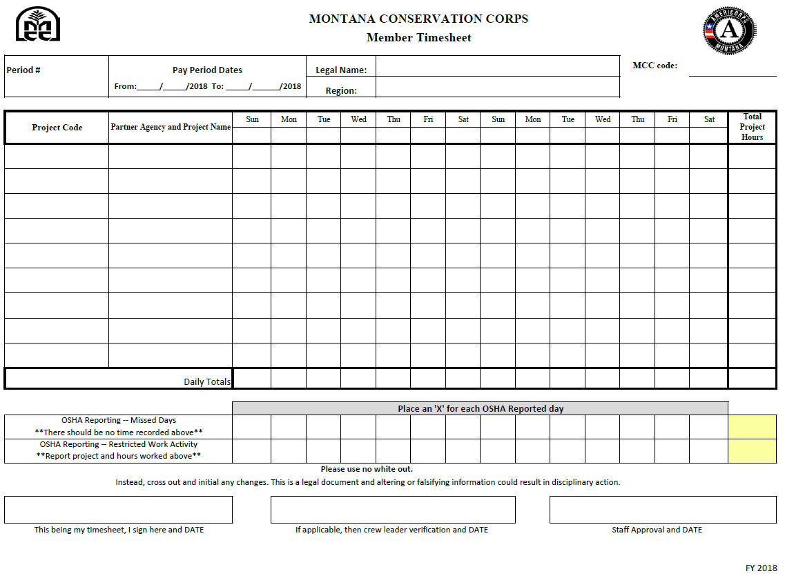

Section A

Section B

Section C

Section D

Guidance
Section A
- Complete all boxes
  - Pay Period # (i.e.—“11”)
  - Pay Period Dates, including year (From: “5/12/19” To: ”5/25/19”)
  - Name—This must be the legal first and last name of the participant. It should match their ID on file with the MCC
  - Region—This may be abbreviated (i.e.—“CD” for “Central Divide”)
  - MCC code -- Initials and last 3 digits of Social Security # (i.e. “John Doe 123 45 6789 = JD789)

Section B
- Fill in appropriate rows
  - Space is provided for writing in the month and day beneath each corresponding day of the week for that pay period. (i.e.—5/10 for Tuesday, May 10; this would go in the second “Tue” of the pay period)
  - Project Codes are an accounting tool which helps distinguish year, region, and specific project. The project code “19C3112A-01” indicates that the project is a 2019 project (“19”), in Central Divide (“C”), and is assigned to a specific project partner and type of work by the Regional Director (“3112”), usually in the order which the RD received the written agreement. Writing in the correct project code is crucial for accounting, billing, and project accomplishment tracking. Project Codes may be found on the Project Information Sheet provided by regional staff at the beginning of a project or training.
  - Partner Agency and Project Name may also be found on the Project Information Sheet, and both are required as a measure to confirm the validity of the project code. Partner Agency names may be abbreviated. (i.e.—Upper Missouri River Breaks National Monument may be written “UMRBNM”, or United States Forest Service may be written “USFS”) Due to the nature of having multiple projects within the same partner agency over the course of a season, including the project name is an important distinction which must be included.
  - Hours worked per day will be written into the intersecting cell of the Project row and the Date column for that day. Hours are to be rounded to the nearest half-hour, and written as a decimal. (i.e.—if you worked eight and a half hours, write “8.5”; if you worked eight hours and fifty minutes, write “9”; never round to the quarter hour: “9.25”)
  - “Footing” and “Crossfooting” are terms which mean adding a column of numbers and verifying that the sum of the totals in the various columns also agrees to the grand total. The final row (“Daily Totals”) and final column (“Total Project Hours”) of the timesheet are established for this purpose. All columns which include entries must be totaled in the bottom row. All rows with numbers must be totaled in the final column. The sum of all the numbers on the bottom row must equal the sum of all the numbers in the final column. Once both sets of numbers align, enter that number into the bottom right cell, representing your total hours for the pay period.

Section C
- OSHA Reporting
  - Basic rule of thumb: This section used when a participant misses days or has restricted work activity due to an injury which also includes a Worker’s Compensation claim. If a person does not have notice from a physician which restricts their duties, do not report in these boxes.
  - Internal light duty does not get marked in these boxes.
  - All days are counted from date of doctor’s note restricting duty until another note from the doctor is presented which releases the individual from light duty. This includes weekends, holidays, unscheduled days, etc.

Section D
- Correct mistakes
  - This section includes a statement about correcting mistakes. As a legal document, no White Out is to be used. If there are enough errors, strikethroughs and corrections to render the document illegible or messy, the participant should be asked to complete a new timesheet. (Generally limited to three corrections per sheet.)
- Verify and sign
  - The participant should review their own timesheet, correct any mistakes, then sign their own timesheet in the bottom left box, dating next to their signature. If the participant is a Crew Member, their Crew Leader should review Sections A and B, verifying completeness and accuracy, and then sign and date in the middle box at the bottom. If a Crew Leader’s signature is illegible, they should print their name beneath their signature. Once staff receives the timesheet, they should review Sections A, B, and C for completeness and accuracy, and then sign and date in the bottom right box, dating next to their signature. If staff’s signature is illegible, they should print their name beneath their signature. Printing beneath the illegible signatures establishes who the accountable party is for verifying a participant’s hours served, it is a best practice which allows auditors to recognize that MCC staff is monitoring participant service hours.

Submitting Timesheets
During the spring, timesheets should be separated by program and submitted alphabetically within that program. Once Crew Members arrive, timesheets should be separated by program and then by crew. Within each crew, the Crew Leader timesheets should be the first sheet or two, followed by the Crew Member timesheets, in alphabetical order within the crew. Contact the Payroll Specialist in the State Office if you have questions about the order or the lead sheet.

Setting Standards
In addition to being a legal document, the timesheet is one of the first opportunities to establish the expectation of accuracy with tracking systems as well as the completeness and legibility of administrative paperwork. Incomplete or incorrect timesheets should be returned for correction to the participant who completed the form. If it is a Crew Member’s timesheet which was verified by a Crew Leader and still submitted incomplete or incorrectly, the form should be returned to the Crew Leader to then have their member fix any errors or omissions. Holding participants accountable to these expectations will be one of the first places staff or leaders may choose to use the behavior change process. Use judgment depending on the individual and the circumstances, but also recognize that unchecked lack of regard (or understanding) for paperwork will establish a precedent that will be hard to curb later in the season, especially knowing that the amount of participants and accompanying paperwork will only increase as the season progresses. Holding ourselves accountable early on will provide the model to use when holding others accountable to established standards.

