MCC ELECTRONIC TIME ENTRY

OVERVIEW:

All MCC Conservation Interns/Fellows are enrolled into terms of service as AmeriCorps members when they join the program. AmeriCorps terms are measured in hours served, therefore AmeriCorps member timesheets are of the highest importance and must be completed in accordance with Federal regulations. Members are paid a biweekly living allowance and the amount paid is the same regardless of the number of hours served. In order to successfully complete their AmeriCorps term, interns must complete a minimum of 450hours of service, and fellows must complete 675 hours of service.

WHAT TO RECORD:

* Only hours spent working, completing administrative duties, or completing MCC programmatic activities are to be documented on the timesheet. Members do not receive hours for vacation days, sick days, or holidays.
* Members who will be working/living in the field will only count hours when they are working, completing administrative duties, or completing MCC programmatic activities. General hours spent in camp are not counted towards the service term.
* Hours spent commuting to and from a worksite may be documented on the timesheet and should be documented under the correct activity description language.
* Members must document a lunch break each day on their timesheet. If a member will be completing hours in the evening they must document a break in between events.

TIMESHEET ACCESS

Access your timesheet with - <https://mcc.verticalits.com/EWS/>  
(bookmark this link as you will use it daily)

ACCOUNT SET UP

1. Click **ACCOUNT SETUP**
2. **EMPLOYEE ID** = First & Last initials of your legally given name and last 3 of your social security number (EX: AD123)
3. **BIRTHDAY:** XX/XX/XXXX
4. **USER ID** = Same as Employee ID- first and last initial and last 3 of your social *This is also your MCC Code
5. **PASSWORD** = 6 character password! Keep this info someplace safe
6. Select *Create or Update* this will kick you back out to the log-in screen. Log in with your Employee ID/ MCC code and created password.

ENTERING HOURS

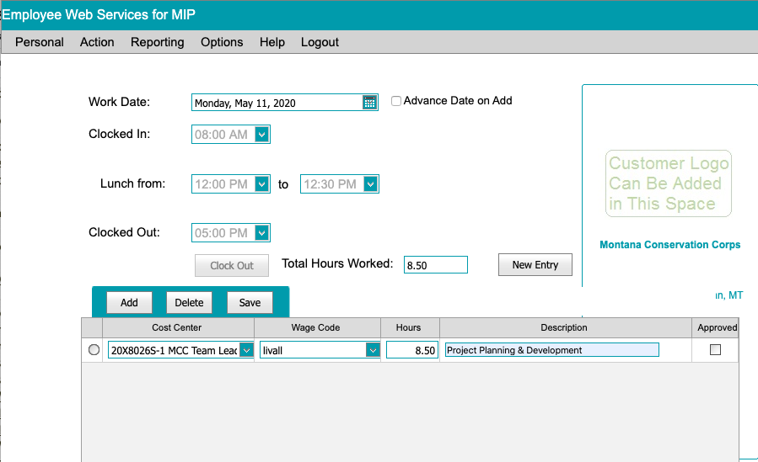

1. Log in to account
2. Select **ACTION** from the top toolbar
   1. → **TIME ENTRY**
   2. → **WORK DATE \***Check to ensure on the correct date
   3. → **CLOCK IN** *Select time to nearest half hour NO QUARTER TIMES
   4. → **ENTER LUNCH START & END** *ALWAYS enter a lunch - enter lunchtimes to nearest half-hour NO QUARTER TIMES
   5. → **CLOCK OUT** *Select time to nearest half hour NO QUARTER TIMES
3. Select **CLOCK OUT** button Your total hours worked will appear. You will then see a row below appear with a Cost Center, Wage Code, Hours and Description columns.
4. From the generated box below CLOCK OUT button
   1. → **ALLOW AUTOFILL**
   2. → **DESCRIPTION ENTRY** **Capture the OVERALL BULK of the day with an option from the below description list. \*\***ONLY use language from the below Activities/Descriptions list.**

ACTIVITIES/ DESCRIPTIONS INCLUDE:

|  |  |
| --- | --- |
| **DESCRIPTION LANGUAGE TO ENTER** | **EXAMPLES OF THIS TYPE OF WORK *DO NOT ENTER THIS INTO TIMESHEET** |
| 1. RESEARCH/MONITORING | Data collection, inventory, surveys, tracking |
| 2. HABITAT RESTORATION | Invasive species removal, planting trees, watering trees |
| 3. TRAIL WORK | Trail maintenance |
| 4. GENERAL MAINTENANCE | Fencing, campground maintenance, installing signs |
| 5. EDUCATION/OUTREACH | Presentations, visitor center programs, user engagement |
| 6. PROJECT PLANNING & DEVELOPMENT | Planning or developing future projects |
| 7. PROGRAM REPORTING | Program reporting, site reporting, evaluations, MCC site visits |
| 8. *TRAINING EVENT NAME* | Structured, formal training (this should not include basic hands-on training or office orientation) should be entered as the event name. For example at the start of your term you participated in a structured MCC training, enter this time on your timesheet as MCC ORIENTATION |